

Issued by StateAdministration for Market Regulation

Standardization Administration of the People's Republic of China

Implementationdate: 2020-03-01

Issue date: 2019-08-30

**General specifications of ground robots for search and rescue in ruins**

地面废墟搜救机器人通用技术条件

*(English Translation)*

GB/T 37703—2019

**National Standard of the People’s Republic of China**

ICS 29.060

L 66

Contents

Foreword III

1Scope 1

2Normative references 1

3Terms and definitions 2

4Classification and model code 3

4.1Classification 3

4.2model code 4

5Technical requirements 5

5.1Basic requirements 5

5.2Appearance and structure 5

5.3Mobile performance 6

5.4Control performance 6

5.5Operational performance 6

5.6Communication performance 7

5.7Safety protection performance 7

5.8Environmental adaptability 7

5.9Continue working 7

5.10Reliability requirements 7

6Test method 7

6.1Appearance and structure inspection 7

6.2Mobile performance test 8

6.3Control performance test 13

6.4Operational performance test 14

6.5Communication performance test 16

6.6Safety protection performance test 16

6.7Environmental adaptability test 16

6.8Continuous working time test 16

6.9Reliability test 17

7testing regulations 17

7.1Inspection classification 17

7.2Test items 17

7.3Factory inspection 18

7.4Type test 18

8Signs,instruction manual,packaging,transportation, storage 19

8.1Signs 19

8.2Instruction Manual 19

8.3Packaging 19

8.4Transportation 19

8.5Storage 19

Annex A Test Objectives 20

Bibliography 22

Foreword

SAC/SWG 13 isin charge of this English translation. In case of any doubt about the contents of English translation, the Chinese original shall be considered authoritative.

This document is drafted in accordance with the rules given in GB/T 1.1-2009*Directives for standardization—Part 1: Structure and drafting of standards*.

Attention is drawn to the possibility that some of the elements of this standard may be the subject of patent rights. The issuing body of this document shall not be held responsible for identifying any or all such patent rights.

This standard was proposed and prepared by SAC/SWG 13 (Standardization Working Group 13 on Special Task Robots of Standardization Administration of China).

General specifications of ground robots for search and rescue in ruins

1Scope

This standard specifies the terms and definitions, classification and model codes, technical requirements, test methods, inspection rules, signs, instructions for use, packaging, transportation, storage, etc., of ground robots for search and rescue in ruins.

This standard is applicable to ground robots for search and rescue in ruins systems that can move on the ground, enter the environment of building ruins, and perform emergency rescue tasks.

This standard is not applicable to flying search and rescue robot systems.

This standard is not applicable to ground robots for search and rescue in ruins used in special environments such as explosive, nuclear radiation, and high temperatures, etc.

2Terms and Definitions

The following documents are indispensable for the application of this document. For dated reference documents, only the dated version applies to this document. For undated reference documents, the latest version (including all amendments) is applicable to this document.

GB/T 191 Packaging-Pictorial making for handling of goods.

GB/T 2423.7-2018Environmental testing-Part 2: Test methods-Test Ec: Rough handling shocks,primarily for equipment-type specimens

GB 2894 Safety signs and guideline for the use

GB/T 4025-2010Basic and safety principles for man-machineinterface,making and identification-Coding principles for indicators and actuators

GB/T 4208-2017 Degrees of protection provided by enclosure (IP code)

GB 5226.1-2008 Electrical Safety of Machinery-Electrical Equipment of machines-Part 1: General requirements

GB/T 7251.8-2005Low-voltage switchgear and controlgear assemblies-General technology requirement for intelligent assemblies

GB/T 9969General principles for preparation of instructions for use of industrial products

GB 11533Standard for logarithmic visual acuity charts

GB/T 12643-2013Robots and Robotic devices-Vocabulary

GB/T 13384General specifications for packing of mechanical and electrical product

GB/T 16754-2008Safety of machinery-Emergency stop-Principles for design

GB/T 36321Special robot classification, symbol, mark

GB/T 36239-2018Special Robot-Terms

GB 50171Code for construction and acceptance of switchboard outfit complete cubicle and panel, cabinet and secondary circuit electric equipment installation engineering

JB/T 8896-1999Industrial robot-Acceptance rules

3Terms and definitions

For the purposes of this document, the terms and definitions given in GB/T 12643-2013, GB/T 36239-2018 and the following apply.For ease of use, some terms and definitions in GB/T 12643-2013 and GB/T 36239-2018 are repeatedly listed below.

3.1

ruins

temporary stable state or unstable state of the structure formed by which damage or collapse of the building structure due to external force

3.2

ground robot for search and rescue in ruins

mobile robot performing search and rescue tasks with assisting and/or substitutes human into the building ruin environment, which is generally composed of mobile platforms, control systems, detection devices, auxiliary rescue devices, communication devices, control units, etc.

3.3

mobile platform

carrier that can change the overall pose of the mobile robot.

[GB/T 36239-2018, definition 2.1.8]

3.4

control system

system with both logic control and power functions that can control and monitor the mechanical structure of the robot and communicate with the environment (equipment and user)

[GB/T 12643-2013, definition 2.7]

3.5

detection device

device for capturing information about the environment and targets to be searched and rescued, etc.

3.6

Auxiliary rescue device

device that delivers water, gas, nutrient solution, drugs, tools and other rescue materials to targets to be searched and rescued that trapped in the ruins

3.7

communication device

device that realizes information transmission between the robot and the control unit

3.8

entrance

entrances for robots to enter and exit the ruins, including but not limited to the entrances naturally formed by collapsed buildings and put up by rescuers.

3.9

operation control unit

device realizing the operation and control of robots by the information interaction between operators and the robots

[GB/T 36239-2018, definition 2.5.2]

3.10

teleoperation control

operator continuously controls the force and movement of the remote robot or robotic device from a local location, and performs expected task purposefully

Note: Rewrite GB/T 36239-2018, definition 2.3.18.

3.11

semi-autonomous control

based on the current state and perception information, the control signal is partially derived from the robot system to perform expected tasks purposefully

3.12

autonomous control

Based on the current state and perception information, the control signals are all derived from the robot system and the expected task will be performed purposefully

Note: Rewrite GB/T 12643-2013, definition 2.2

4Classification and model code

4.1 Classification

4.1.1According to function, it can be divided into:

a)Search type;

b)Auxiliary rescue type;

c)Compound type.

4.1.2According to the control mode, it can be divided into:

a)Remote control;

b) Semi-autonomous control;

c)Autonomous control.

4.1.3According to the communication method, it can be divided into:

a)Wired communication;

b)Wireless communication;

c)Both wired and wireless communication.

4.2Model Code

The model code of the ground robot for search and rescue in ruins is composed of The codes of the company, name, industry, space, movement mode， function and design.The coding rules shall comply with the requirements of GB/T 36321. The design code is composed of product feature code and design sequence code, which is customized by the enterprise. The format is as follows.



Figure 1 Model code structure

Among them, the name code, space code and function code are "TZ", "DM" and "SJ" respectively. The product feature code is composed of 6 letters, indicating the subdivision function classification code, the control type classification code and the communication type classification code, see Table 1, Table 2, and Table 3 respectively.

Table 1 Subdivision function classification code

|  |  |  |
| --- | --- | --- |
| Types | Chinese Pinyin | Symbolic basis |
| Search type | Sou Suo | SS |
| Auxiliary rescue type | Fu Zhu Jiu Yuan | FJ |
| Compound type | Fu He | FH |

Table 2 Control type classification code

|  |  |  |
| --- | --- | --- |
| Types | Chinese Pinyin | Symbolic Basis |
| Remote control | Yao Kong | YK |
| Semi-autonomous control | Ban Zi Zhu | BZ |
| Autonomous control | Zi Zhu | ZZ |

Table 3 Communication type classification code

|  |  |  |
| --- | --- | --- |
| Types | Chinese Pinyin | Symbolic Basis |
| Wired communication | You Xian | YX |
| Wireless communication | Wu Xian | WX |
| Both wired and wireless communication | Jian Bei | JB |

Example: A transformable ground robot for search in ruins produced by the National Search and Rescue Company, which is crawler type, remote control, wireless communication, design prototype, its model code is: Guosou TZDMLDSJ-SSYKWX01.

5Technical requirements

5.1 basic requirements

The basic functional configuration of the ground robots for search and rescue in ruins should meet the requirements of Table 4.

Table 4 Basic function configuration table)

|  |  |  |  |  |
| --- | --- | --- | --- | --- |
| Function | | Search type | Auxiliary Rescue Type | Compound Type |
| mobile | | ▲ | ▲ | ▲ |
| control | | ▲ | ▲ | ▲ |
| Operation function | environmental information acquisition | ▲ | ▲ | ▲ |
| life search | ▲ |  | ▲ |
| auxiliary rescue |  | ▲ | ▲ |
| Communication | | ▲ | ▲ | ▲ |
| Safety Protection | operation Safety | ▲ | ▲ | ▲ |
| abnormal alert | ▲ | ▲ | ▲ |
| Environmental adaptability | temperature and humidity resistance | ▲ | ▲ | ▲ |
| dustproof and waterproof | ▲ | ▲ | ▲ |
| drop resistance | ▲ | ▲ | ▲ |
| continuous working time | | ▲ | ▲ | ▲ |
| reliability | | ▲ | ▲ | ▲ |
| Description: "▲" indicates the function that the classified robot shall be configured，and"-" indicatesthat the classified robot does not have this function. | | | | |

5.2 Appearance and structure

The appearance and structure of the robot shall conform to:

a) The surface shall not have cracks, obvious depressions and deformations. There shall not be other quality defects that damage the strength of the structure;

b) The metal parts shall not be corroded;

c) All connectors and fasteners shall have anti-loosening measures.

5.3Mobile performance

The robot shall be able to enter the ruins with the size of the entrance no greater than 0.4 m (width) × 0.4 m (height).

When the size of the entrance to the ruins is less than 0.1 m (width) × 0.1 m (height), the minimum entry distance of the robot shall be greater than 5 m.

When the size of the entrance to the ruins is greater than 0.1 m (width) × 0.1 m (height), the robot's mobile performance shall meet the requirements of Table 5.

Table 5 Mobile performance requirements

|  |  |
| --- | --- |
| mobile performance parameters | Requirements |
| walking speed | Not less than 0.2 m/s |
| obstacle clearance height | Not less than 0.25m |
| climbing angle | Not less than 30 ° |
| climbing stairs size | Step width is not less than 0.26 m, height is not greater than 0.175 m |
| ditch width | Not less than 0.20m |
| turning radius | less than 0.1m |

5.4Control performance

The robot’s action shall be consistent with the operating instructions, and the delay time should be less than 0.5s.

Operation instructions shall have interlocking capability.

5.5Operation performance

5.5.1Search robot

The performance of search robots shall meet the following requirements:

a) It shall be able to detect the sound of the rescued person within a radius of 2 m in real-time, the intensity of the point sound source is 40 dB～80 dB, and the reliability is greater than 80%;

b) Under the condition that the light intensity is less than 0.001 lx, it shall be able to obtain and clearly present the environment image in front of the robot within 2 m, and the reliability is greater than 80%;

c) The temperature measurement error shall be less than 0.5 ℃.

5.5.2Auxiliary Rescue Robot

The operating performance of the auxiliary rescue robot shall meet the following requirements:

a) When the light intensity is less than 0.001 lx, it should be able to obtain and clearly present the environment image in front of the robot within 2 m, and the reliability is greater than 80%;

b) The temperature measurement error should be less than 0.5 ℃;

c) The measurement error of oxygen concentration should be less than 5%;

d) It shall be equipped with water and air supply. The rate of water flow should be no less than 45 ml/min, and the rate of air flow should be no less than 800 ml/min.

5.6Communication Performance

5.6.1 It shall have the transmission capability of data, voice and image.

5.6.2 When using wireless communication, the communication distance should be greater than 100 m in an open and unobstructed condition.

5.6.3 When using wired communication, the cable length should be greater than 20 m.

5.7Safety protection performance

5.7.1 The installation and wiring of the robot body and the control unit shallcomply withthe requirements of GB 50171.

5.7.2 The technical characteristics of the robot body and the control unit shall comply withthe requirements of GB/T 7251.8-20055.2, 5.4, and 5.5.

5.7.3 It has an emergency stop button, which shallcomply withthe requirements specified in GB/T 16754-20084.4.

5.7.4 The power circuit and the shell shall be insulated, and the insulation resistance should not be less than 2 MΩ.

5.8Environmental adaptability

It shall be able to maintain normal when used under the conditions of temperature and humidity resistance in Table 6.

Table 6 Conditions ofTemperature and humidity resistance

|  |  |  |  |
| --- | --- | --- | --- |
| environmental conditions | working conditions | | |
| general condition | medium condition | bad conditions |
| ambient temperature | 0 ℃~+40 ℃ | -20 ℃~+55 ℃ | -50 ℃~+85 ℃ |
| relative humidity | 50%~90% | | |

5.8.2 The Ingress Protection rating is not lower than IP54.

5.8.3 The robot shall be able to work normally after falling to the ground from a height of not less than 0.5 m.

5.9Continuous work

When there is no external power source, the continuous working time shall not be less than 1 h.

5.10Reliability requirements

The mean time between failure should shall not be no less than 72 h, and the mean time between repair shall not be no more than 3 h.

6Test method

6.1Appearance and structure inspection

Visual observation and inspection shall be carried out under normal environmental conditions while the robot is in the initial state.

6.2Mobile performance test

6.2.1Entrance

Establish a rectangular entrance with width l1 and height l2, as shown in Figure 2. Operate the robot to enter the rectangular passage stably and safely, and visually check whether the robot can pass through.

The unit is meter



|  |  |
| --- | --- |
| *l*1 | *l*2 |
| 0.4 | 0.4 |

Description：

1 -Building Wall

2 -Entrance

Figure 2 Schematic diagram of rectangular channel

6.2.2Entering distance

Establish a U-shaped channel as shown in Figure 3, the internal cross-sectional size of the channel is l4×l5, operate the robot to enter the channel, and move along the channel, and measure the farthest distance the robot enters. No manual intervention is allowed during the testing process.

The unit is meter



a) Dimension of the U-shaped channel b) Dimensions of the internal cross-sectional space of the U-shaped channel

|  |  |  |  |  |
| --- | --- | --- | --- | --- |
| *l*1 | *l*2 | *l*3 | *l*4 | *l*5 |
| 2 | 1 | 2 | 0.1 | 0.1 |

Figure 3 Schematic diagram of U-shaped channel

6.2.3walking speed

Establish a straight path on the cement floor as shown in Figure 4, the path length l is not less than 20 m, and the path line is painted with 0.08 m wide yellow paint. The operating robot is required to run continuously, keep the moving chassis covering the path line, complete one path, and use a stopwatch to time the path. The length of the path divided by the time is the walking speed. Manual intervention is not allowed during the test, and the test is repeated 3 times, and the maximum value of the speed is taken as the walking speed.



Description：

A-Starting point

B-End point

Figure 4 Schematic diagram of a straight path environment

6.2.4 obstacle clearance height

Establish a vertical barrier as shown in Figure 5, consisting of a starting area A, a vertical barrier B, a landing area C and a wall D, and the surface material is OSB (Oriented Strand Board). During the test, the robot starts to move from the starting area and climbs over the vertical obstacle to reach the landing area. If it successfully crosses the vertical obstacle, a successful test is recorded; if a crossing failure or failure occurs during the traversing, a failed test is recorded. Manual intervention is not allowed in the test process, the test is repeated 10 times, and one failure is allowed.

The unit is meter



|  |  |  |  |  |
| --- | --- | --- | --- | --- |
| *l*1 | *l*2 | *l*3 | *l*4 | *l*5 |
| 1.2 | 2.4 | 0.25 | 2.4 | 0.45 |

Description：

A-Starting Area；

B-Vertical Obstacle；

C-Landing Area；

D -Enclosure.

Figure 5 Schematic diagram of vertical obstacle test environment

6.2.5 climbing angle

Establish the inclined plane test environment as shown in Figure 6. The inclined plane surface material is OSB (Oriented Strand Board), and 4 stops (A, B, C, D) are designed on the plane to form horizontal lines, diagonal lines and vertical lines. Path AB, AC, AD. During the test, the robot starts from point A and arrives at point B or point C or point D along the path line. The width of the robot's deviation from the path is not more than half the width of the robot. If the climb is successful, record a successful test; if the robot deviates from the path width more than half of the robot's width or malfunctions during the climb, record a failed test. Manual intervention is not allowed in the test process. The robot should complete three path tests.Each path repeats the test 10 times, and one failure is allowed.

The unit is meter

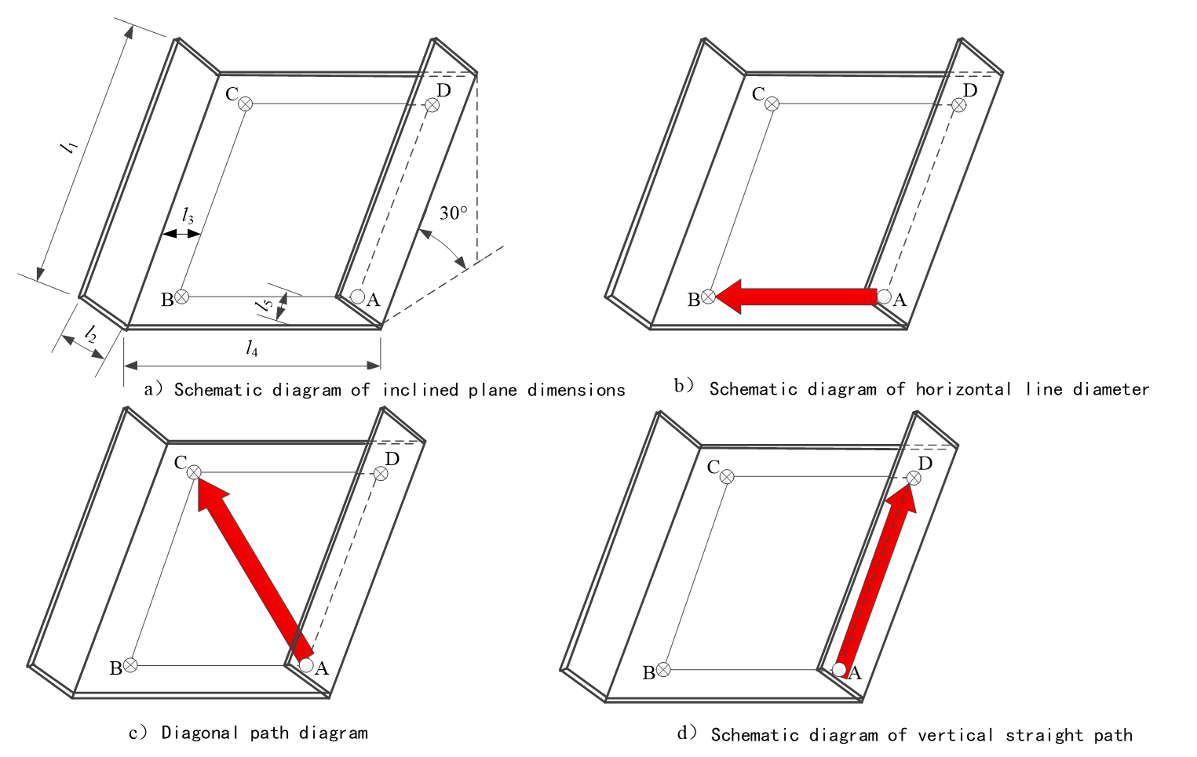

|  |  |  |  |  |
| --- | --- | --- | --- | --- |
| *l*1 | *l*2 | *l*3 | *l*4 | *l*5 |
| 4 | 0.2 | 0.5 | 4 | 0.5 |

Description：

A、B、C、D-Stop point。

Figure 6 Schematic diagram of inclined plane

6.2.6 Ability to climb stairs

Establish the staircase test environment as shown in Figure. 7, the step height *l*2, the width *l*4, and the surface material is OSB. During the test, robot starts moving from the platform at the bottom of the stairs and climb the test stairs to reach the center of the top platform. If the robot successfully traverses the stairs, record a successful test; if a traversal failure or malfunction occurs during the traversing, record a failed test. Manual intervention is not allowed in the test process, the test is repeated 10 times, and one failure is allowed.

The unit is meter



|  |  |  |  |  |  |  |  |
| --- | --- | --- | --- | --- | --- | --- | --- |
| *l*1 | *l*2 | *l*3 | *l*4 | *l*5 | *l*6 | *l*7 | *l*8 |
| 1.2 | 0.175 | 1.24 | 0.26 | 2.76 | 1.2 | 1.05 | 0.2 |

Figure 7 Schematic diagram of the staircase test environment

6.2.7 the width of ditch crossing

The test environment shown in Figure 8 is constructed, which is composed of start area A, landing area C, horizontal trench B and wall D, and the surface material is OSB. During the test, the robot moved from the center of the starting area to the center of the landing area through the horizontal trench. If the robot arrives at the landing zone from the start zone, record a successful trial. If the robot does not reach the landing zone from the start zone, record a failed test. It is required that no manual intervention is allowed in the test process, the test is repeated 10 times, and one failure is allowed.

The unit is meter



|  |  |  |  |  |  |
| --- | --- | --- | --- | --- | --- |
| *l*1 | *l*2 | *l*3 | *l*4 | *l*5 | *l*6 |
| 1.2 | 2.4 | 0.25 | 0.2 | 2.4 | 0.45 |

Description：

A-Starting Area；

B-Horizontal Groove；

C-Landing Area；

D -Enclosure.

Figure 8 Schematic diagram of horizontal ditch test environment

6.2.8 turning radius

Operate the ground robot for search and rescue in ruins to rotate clockwise and counterclockwise on a horizontal plane, and measure the distance from the center of rotation of the robot to the centroid of the robot. It is required to rotate clockwise to complete the test 5 times, and rotate counterclockwise to complete the test 5 times. Take the measuredminimum value as the turning radius.

6.3 Control performance test

6.3.1 button function check

The layout of the buttons and switches of the robot and the control unit is reasonable, and the operation is convenient. All the ON/OFF actions of the buttons are flexible and reliable, and complete the command correctly.

6.3.2 display check

The color of the inspection button and indicator light shallcomply with the requirements of GB/T 4025-2010,4.2.1.1, and the function shall be normal.

6.3.3 Motion check

Realize all command actions through the control unit, check whether the robot actions are correct, and check all interlocking functions. The delay time adopts the round-trip delay measurement method. The control unit starts timing after sending the instruction. After the robot receives the instruction, it immediately sends the response data; after the control unit receives the response data, it sends the instruction again, repeats the test 1000 times and then stops the timing and takes the timing. One thousandth of the time interval is the delay time.

6.4 Operation performance test

6.4.1 Sound inspection test

Establish a test environment as shown in Figure 9, the noise of the test environment is less than 40 dB, the test target should meet the requirements of Annex A, and the distance l between the robot’s control unit and the test target is not less than 10 m. During the test, the robot moves along the test target's circumferential path line, stops at 4 test points in sequence, searches for sound signals, obtains sound signals at all 4 test points, and records as one successful test. The test is required to be repeated 10 times, and 2 failures are allowed, and the sound information can be accurately obtained at the control unit.



Description：

A-Control Unit；

l-The distance between the robot control unit and the test target

Figure 9 Schematic diagram of sound test environment and wireless communication test environment

6.4.2 Visual inspection test

Establish a confined space as shown in Figure 10, with no light source in the space, and the standard visual acuity chart meets the requirements of GB/T 11533. The visual acuity of the inspector is not less than 5.0, the illuminance of the inspection environment is not less than 300 lx, and direct sunlight or strong light is avoided. The control unit is used to display the on-site video information collected by the robot, and the inspector can clearly observe the "E"-shaped optotype with a vision above 4.0 in the standard visual acuity chart. The test is required to be repeated 10 times, and 2 failures are allowed.

The unit is meter



|  |  |  |  |
| --- | --- | --- | --- |
| *l*1 | *l*2 | *l*3 | *l*4 |
| >1.2 | >1.2 | >3.2 | 2 |

Description：

A-Test Stop Line

E-Standard Visual Acuity Chart.

Figure 10 Schematic diagram of visual test environment

6.4.3 Temperature measurement test

Compare the ambient temperature measured by the robot with the temperature measured by the standard instrument.

6.4.4 Oxygen concentration measurement test

Inject a standard concentration oxygen to the oxygen sensor of the robot, compare the measured value of the robot with the standard value.

6.4.5 water supplyfunction test

Operate the robot to perform awater supply operation for 30 s. Use a measuring cup with an index value not greater than 1 mL to measure the total water supply. The total water supply divided by the operation duration is the rate of water supply.

6.4.6 Gas supplyfunction test

Operate the robot to perform gas supply operations for 30s.Measure the gas flow with a gas flow meter with an accuracy of not less than 2.5.

6.5Communication performance test

6.5.1Robot transmission voice, data and image function test

Check the functions of robot transmitting voice, data and image by visual inspection functions.

6.5.2 Wireless communication test

The test shall be carried out on a flat road with a length greater than 120 m and a width greater than 15 m. A test environment without external interference as shown in Figure 9 shall be established. The test target shall meet the requirements of Annex A. The distance between the control unit and the test target shall not be less than 100 m. During the test, the robot moves along the path of the test circle, stops at 4 test points in sequence, and stops after searching for warning signs. It is required that at 4 test points, the control unit can present the warning signs images and sounds.

6.5.2Wired communication test

Refer to 6.5.2 to establish a test environment. The control unit is required to be no less than 20 m away from the test target. At 4 test points,the control unit can present warning signs images and sounds.

6.6 Safety protection performance test

6.6.1Visually inspect the installation and wiring of the control system to determine whether the test results comply with the requirements of GB 50171.

6.6.2Test the robot body and the control unit as specified in GB/T 7251.8-2005,Clause 7.

6.6.3 Check the emergency stop button, press the emergency stop button to check whether the robot power supply is cut off.

6.6.4 Insulation resistance shall be carried out as specified in GB 5226.1-2008,18.3.

6.7Environmental adaptability test

6.7.1Temperature and humidity resistance environment test shall be carried out as specified JB/T 8896-1999,5.10.

6.7.2Dustproof and waterproof test shall be carried out as specified in GB/T 4208-2017,13.4 and 14.2.4.

6.7.3The drop resistance test shall be carried out as specified in GB/T 2423.7-2018,5.2 Method 1.

6.8Continuous working time test

Operate the robot with the robot control unit, and continue to perform search and rescue operations for 1 h. The robot is not permissible to supplement energy during the test.

6.9 Reliability test

Carry out the MTBF and MTBRtest according to the agreement in the user specification.

7Inspection rules

7.1Inspection classification

7.1.1 Product inspection is divided into factory inspection (delivery inspection) and type test (routine inspection).

7.1.2The various tests that shall be carried out when the product is delivered are collectively referred to as the factory inspection.

7.1.3 To conduct a comprehensive assessment of product quality, and to conduct all inspections in accordance with the technical requirements specified in the product standards, is called type test.

7.1.4 Type test shall be taken for robots in any of the following situations:

a) When newly designed or old robots are trial produced in the interplant transfer procedure;;

b) Products that have been finalized, such as major changes in design, key processes, and materials that may affect product performance;

c) Normally produced products, every 3 years or when the cumulative number is greater than 50;

d) When production is resumed after 3 years of suspension;

e) When the factory inspection result is quite different from the last type test;

f) When the State Administration for Market Regulation requests the type test.

7.2 Inspection items

The inspection items are shown in Table 7.

Table 7 Inspection items

|  |  |  |  |  |  |
| --- | --- | --- | --- | --- | --- |
| Code | Inspection Items | | experiment method | factory inspection | type inspection |
| 1 | appearance and structure | | 6.1 | ○ | ○ |
| 2 | mobile performance | entrance | 6.2.1 | - | ○ |
|  | enter Distance | 6.2.2 | - | ○ |
| 3 | walking speed | 6.2.3 | - | ○ |
| 4 | obstacle clearance height | 6.2.4 | - | ○ |
| 5 | climbing angle | 6.2.5 | - | ○ |
| 6 | stair climbing ability | 6.2.6 | - | ○ |
| 7 | ditch width | 6.2.7 | - | ○ |
| 8 | turning radius | 6.2.8 | - | ○ |
| 9 | control performance | button function | 6.3.1 | ○ | ○ |
| 10 | display | 6.3.2 | ○ | ○ |
| 11 | action | 6.3.3 | ○ | ○ |
| 12 | operational performance | sound | 6.4.1 | ○ | ○ |
| 13 | visual | 6.4.2 | ○ | ○ |
| 14 | temperature, oxygen | 6.4.3、6.4.4 | ○ | ○ |
| 15 | Deliver water,airs | 6.4.5、6.4.6 | ○ | ○ |
| 16 | communication performance | | 6.5 | ○ | ○ |
| 17 | safety protection performance | | 6.6 | ○ | ○ |
| 18 | environmental adaptability | temperature and humidity resistance | 6.7.1 | - | ○ |
| 19 | dustproof and waterproof | 6.7.2 | - | ○ |
| 20 | drop resistance | 6.7.3 | - | ○ |
| 21 | continuous working time | | 6.8 | - | ○ |
| 22 | reliability | | 6.9 | - | ○ |
| NOTE: "○" means that the item needs to be inspected. | | | | | |

7.3factory inspection

7.3.1 Each robot should undergo ex-factory inspection, and the quality inspection department of the manufacturing unit is responsible for the implementation.

7.3.2 After all the items in the factory inspection are qualified, the product qualification certificate will be issued.

7.3.3 When an item does not meet the requirements or fails during the inspection, the cause shall be found out, repaired, and the item shall be re-inspected. In the re-inspection, when the item does not meet the requirements or fails again, the product is judged as unqualified.

7.4 Type test

7.4.1 The robot type test shall be a product that has passed the factory inspection, and the number of inspected units shall be specified by the product standard.

7.4.2 Type test shall be carried out by the quality inspection department of the manufacturing unit, or carried out by the unit designated by the superior competent department.

7.4.3 When any item in the inspection does not meet the requirements or malfunction, the cause shall be found out and repaired. After repair, the inspection shall be restarted from that item. If a failure occurs again or a certain item does not meet the requirements, after the cause is found out, an analysis report should be submitted, and after the repair, the type inspection should be re-conducted. In the re-inspection, when the item does not meet the requirements again, a comprehensive analysis shall be conducted, and all measures shall be taken for the batch of products, and the type inspection shall be re-conducted. The type-inspected samples shall be printed with marks.

7.4.4Issue a type test report after inspection.

8Signs, instruction manual, packaging, transportation, storage

8.1 Signs

The ground robot for search and rescue in ruinsshall have a permanent label. The label kshall include: product name, model code, rated voltage and power supply, production number, production date, producer’s name, factory address, etc.

8.2Instruction manual

The instruction manual is compiled as specified in GB/T 9969

8.3 Packaging

8.3.1　 The packaging box should be made of lightweight materials, complying with the requirements of GB/T 13384, and resistant to vibration and drop.

8.3.2　 The packaging sign shall comply with the requirements specified in GB/T 191.

8.3.3　 Use cushions for positioning inside the packing box, the robots should not move or collide with each other.

8.3.4　 The packing box should be dust-proof and rain-proof.

8.3.5　 The packaging box shall be accompanied with a packing list, product certificate, user manual, spare parts, and special tools.

8.4 Transportation

Robots should be handled with care during transportation and loading/unloading, strictly prohibiting throwing and collision to prevent severe impacts and vibrations. Avoid direct exposure to rain and snow and contact with corrosive gases.

8.5 Storage

8.5.1It should be stored indoors or in a dry place that can avoid rain, snow, wind, and sand. The ambient temperature is -10 ℃～+50 ℃, and the relative humidity should be less than 80%.

Robots should be stored indoors or in a dry place that can avoid rain, snow, windand sand, and should not be stored with corrosive materials. The storage temperature should be between -10℃ to +50℃, and the relative humidity should be less than 80%.

8.5.2Prevent rain and moisture, andshall not be placed together with corrosive materials.

Annex A

(annexinformative)

Test Target

The test target is a plastic drum with a diameter of not less than 0.5 m and a capacity of not less than 200 L. Four holes with a diameter of 0.2 m are symmetrically opened on the outer wall of the drum as the sound source holes, and the distance between the center of the sound source hole and the bottom surface of the drum is l1. The sound source with an intensity of 40 dB～80 dB is located at the center line of the drum at a distance of l3 from the bottom of the drum.

On the outer wall of the drum, 4 warning signs such as "No stopping", "No entry", "No crossing" and "stay clear from the tracks" shall be placed uniformly. The center of the warning sign is at a distance of l2 from the bottom of the drum. The position of the drum opening and warning signs is shown in Figure A.1.

The unit is meters

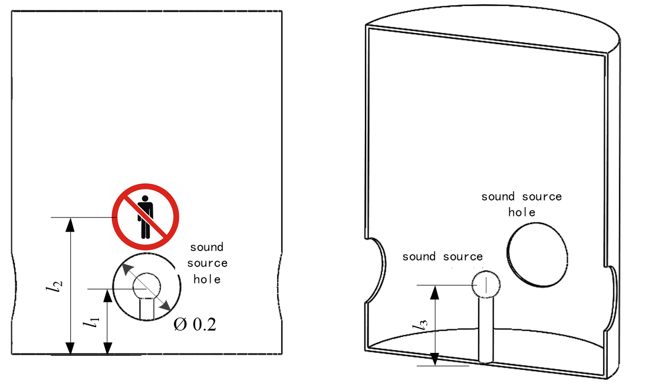

|  |  |  |
| --- | --- | --- |
| *l*1 | *l*2 | *l*3 |
| 0.2 | 0.4 | 0.2 |

Figure A.1 Schematic diagram of the position of the drum and warning signs

The warning signs shall comply with the requirements in GB 2894, see Figure A.2.

|  |  |
| --- | --- |
|  |  |
| Nostopping | No entry |
|  |  |
| No crossing | Stay clear from the tracks |

Figure A.3 Schematic diagram of warning signs

The test station environment consists of the test target and a test circular path line with a radius R of 2 m, and 4 test points are evenly distributed on the circular path. The center of the bottom surface of the test target coincides with the center of the circumferential path line, and the test point corresponds to the warning sign or the sound source hole, as shown in Figure A.3.

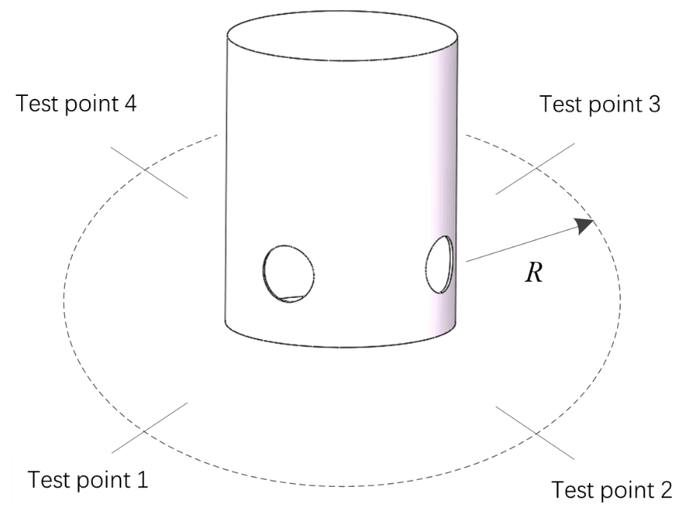

Figure A.4 Schematic diagram of test station environment

References

[1] GB/T 4458.4-2003 Mechanical drawings-Dimensionings

[2] GB 4793.1-2007 Safety requirements for electrical equipment for measurement, control and laboratory use

[3] GB 4943.1-2011 Information Technology Equipment Safety Part 1: General Requirements

[4] GB/T 14691-1993 Technical drawings Lettering

[5] GB/T 18207.1-2008 Terminology for Earthquake Prevention and Disaster Mitigation Part 1: Basic Terminology

[6] GB/T 18207.2-2005 Terminology for Earthquake Prevention and Disaster Mitigation Part 2: Professional Terminology

[7] GB/T 29428.1-2012 Earthquake disaster emergency rescue team rescue operations Part 1: Basic requirements

[8] GB/T 50083-1997 Standard for terminology and symbols for building structure design

_________________________________